# 

# 

**Personal Automated Transport Equipment**

**Period of Performance:** December 16, 2019 – May 11, 2020

**Technical Point of Contact:** Miguel Yamamoto1,Ricardo Colin2, Anna Maka3,

1 Computer Engineering

2 Computer Engineering

3 Computer Engineering

School of Engineering

San Francisco State University

1600 Holloway Ave. San Francisco, CA 94132

Email: {myamamoto1, rcolin, amaka2}@mail.sfsu.edu

**Advisors:** Hamid Mahmoodi

School of Engineering

San Francisco State University

1600 Holloway Ave. San Francisco, CA 94132

Email: mahmoodi@sfsu.edu

**Table of Contents**

**Title i**

**List of Figures iii**

**List of Tables** [**iv**](https://docs.google.com/document/d/1SU562mxBmxqOHPX-gU2n9_bcIJYRnJ3X/edit#heading=h.3znysh7)

**Abstract 3**

**Section 1. Introduction 4**

Section 1.1 Project Goal 4

Section 1.2 Significance 4

**Section 2. Background 4**

Section 2.1 Prior Arts in Research/Commercial Development 4

Section 2.2 Team Member’s Prior Experience 6

Section 2.3 Budget 7

**Section 3. Approach/Design 7**

Section 3.1 Design Objective/Specification 1 7

Section 3.2 Design Objective/Specification 2 9

Section 3.3 Design Objective/Specification 3 10

**Section 4. Results and Discussions 11**

Section 4.1 First Approach 11

Section 4.2 Second Approach 12

Section 4.3 Final Design 14

**Section 5. Self Assessment 15**

Section 5.1 Lessons 15

Section 5.2 Improvements 16

**Section 6. Conclusions 16**

**Reference 17**

**Appendix 18**

## **List of Figures**

Figure 1: OVIS suitcase……………………………………………………………………………………5

Figure 2: Gita Robot……………………………………………………………………………………….6

Figure 3: Potential Design of Cart…………………………………………………………………………7

Figure 4: Hardware design for GPS……………………………………………………………………….9

Figure 5:Hardware Design of Scale……………………………………………………………………....10

Figure 6:Sample Cart……………………………………………………………………………………..12

Figure 7:Body of Cart………………………………………………………………………………….....13

Figure 8:Mounting Motors……………………………………………………………………………….13

Figure 9:Hoverboard Components……………………………………………………………………….13

Figure 10:PIXY2 Camera………………………………………………………………………………...13

Figure 11:Cart Closed Exterior…………………………………………………………………………...14

Figure 12:Cart Open Interior....…………………………………………………………………………...14

Figure 13:Cart Final Components………………………………………………………………………...14

Figure 14:Cart’s Power button and charging port………………………………………………………...14

Figure 15:PS3 Controller..………………………………………………………………………………...15

Figure 16:USB Adapter…....……………………………………………………………………………...15

Figure 17:Cart’s DACs…….……………………………………………………………………………...15

## 

## 

## 

## **Abstract**

The Personal Automated Transport Equipment is a small cart that is designed to hold personal belongings while following its owner’s every move. This cart will also be designed to have sensors that will help the cart avoid obstacles as well as determining the weight of the cart to calculate if the cart will be able to function efficiently. The unique approach of this project is that it would use bluetooth capabilities to move around meaning that it would be really simple to use and accessible to everyone since nowadays everyone has a phone and almost every phone has bluetooth functionality. It can be used by all ages, and prevent or help people with back issues.

## **Section 1. Introduction**

### **Section 1.1 Project Goal**

The goal is to build a personal automated transport equipment to travel with its owner while avoiding obstacles during its travel. It will include a sensor to determine if the cart can function with the weight of the items it is carrying and alert users of any error. Along with designing the cart, the plan is to develop an app to work along with the cart.

### **Section 1.2 Significance**

The main purpose of this project is to build a product that can be useful to everyone. This product is mostly significant to prevent or help people with back issues. Kids as they get older start to receive more schoolwork, and with more work leads to more weight to carry in their backpacks. It has been documented that children carrying heavy loads overtime can lead to health issues later in life. Elderly people or people with disabilities who cannot carry items on their own can use this product to help carry the load. Even if you do not need the help to carry your personal items around, it is nice to have someone or in this case something to help take the weight off.

## **Section 2. Background**

### **Section 2.1 Prior Arts in Research/Commercial Development**

There have been a couple products that have been developed and are being sold that have similar features. The Ovis by ForwardX is a suitcase that is designed to follow you as you walk and avoid obstacles as it moves. The suitcase uses multiple cameras and sensors to self drive. The suitcase uses vSlam which is technology based on computer vision for precise indoor location and positioning. The technology can build a map of an unknown environment and perform location simultaneously. That is where the SLAM comes from, Simultaneously Localization and Mapping. With the vSLAM, the company also developed a neural network algorithm in-house. This is how the suitcase is able to self drive while avoiding obstacles. Because of the technology and sensors that are used, the product is very expensive to purchase. The OVIS is priced at $800.

Another product that has been developed is a product named Gita created by Piaggio Fast Forward. The Gita is very similar to our project; It is a robot designed to carry personal items while it follows you. The Gita uses various cameras and sensors to navigate. Previously the Gita came with a special belt that the owner would wear to connect to the robot via WiFi. Now with a push of a button, the Gita turns on and scans the owner’s legs to pair to follow. The unique part of this product is that it can follow someone up to 22 mph. Because of all its features, this product is very expensive as well. Selling price for a Gita is $3,250

For our project, we do not intend on using cameras as other companies have used. The autonomous cart will be connected to the user’s phone via Bluetooth to move around and sensors will be installed to avoid obstacles. The choice to use Bluetooth instead of cameras is more cost-effective for us and the consumer. Our approach to this product is to make it work efficiently while keeping the cost low. This way we can create a similar product for a lesser value to compete with the other expensive products. Also, with a lower selling cost, more people would be able to purchase this item that needs it.

Sample images:

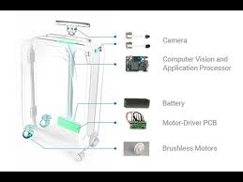

*Figure 1: OVIS suitcase*

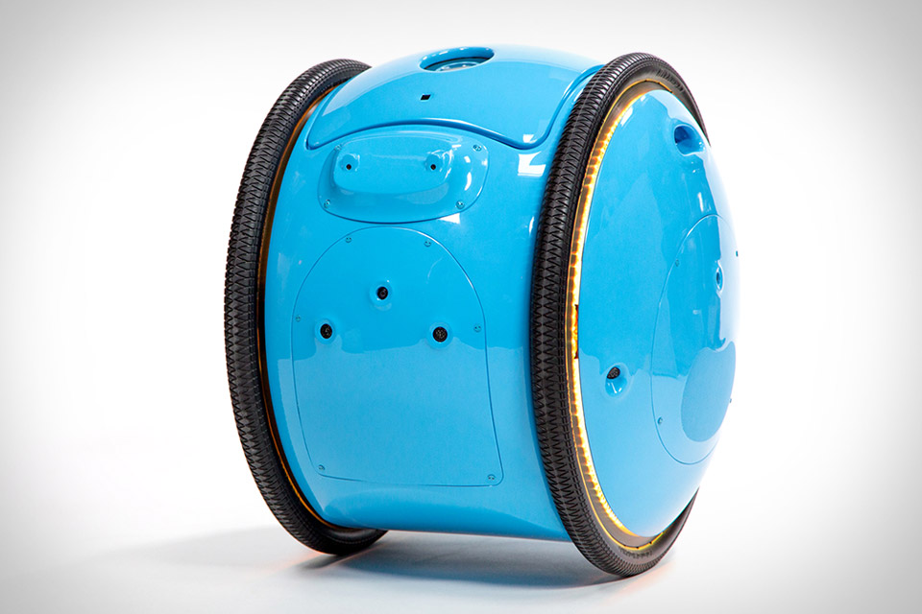

*Figure 2: Gita Robot*

### **Section 2.2 Team Member’s Prior Experience**

Miguel studies Computer Engineering. He has built personal desktop tower with hand picked computer components and a low-noise headphone amplifier In addition, he programmed two 2D games using Java.

Ricardo studies Computer Engineering. He has a broad knowledge in different areas. He has developed websites using software and open source libraries such as Bootstrap, Visual Studios Code, html, java script, css, among others. He developed an application and deployed them for androids and iphones mobile devices. As well as conducted research in EMG and IMU data; classifying them and training the data into gestures with an algorithm that predicts the future gestures. This project is currently working on an android device and the data has been collected using a bluetooth armband. He also has knowledge in circuits and electrical components. Some unique skills are carpentry which would be needed for the construction of the project. Creating the base and connecting all mechanical parts, as well as coding the logic needed for the project to function correctly.

Anna studies Computer Engineering. She has designed a circuit board for a Low-noise

Headphone amplifier. Using programs such as Eagle and LTSpice, to simulate and

design the board. Also has designed and developed software to create a digital music box to acquire audio input, filter audio samples, and output signals to LEDs. Also has skills in carpentry which is needed for building the base of the project.

### **Section 2.3 Budget**

As of now our budget is between $200-$300 to acquire all the parts. We plan on seeking for investors or donations from family and friends. If we cannot get our budget from outside sources we will split the cost equally. Most of our items can be bought in a hardware store and amazon.

## **Section 3. Approach/Design**

### **Section 3.1 Design Objective/Specification 1**

#### Section 3.1.1 Introduction

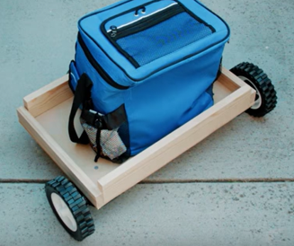

*Figure 3: Potential Design of Cart*

This picture (from google) gives a general idea of what we would want to make our cart. We would want the cart to have wheels so that it can move while at the same time it has enough space for more than one item (not just a lunch bag). For the approach, I will be referring to this picture as a basis.

#### Section 3.1.2 Approach

Our approach for this project is to start ordering parts since we already have a good idea of what we want and how to collect the desired data. We would have two wheels in front that would essentially make the cart move while there are two supporting wheels at the back of the platform. The cart will have a piece of wood in the middle that would separate items that are liquid and items that are non-liquid. We will also extend the wood that is found on the edge a bit higher to prevent items from falling when the cart is moving. The electrical components would be found at the bottom of the cart so it won’t get in the way of putting the items. We were planning to put a rubber substance on the liquid side so that in case of liquid dripping, it will not destroy the wood. Speaking of liquid, we would want to have somewhat of a cover on top of the cart that prevents dust and raindrops from entering. To do so, an approach is having a glass on top of the cart.

#### Section 3.1.3 Anticipated Pitfall and Mitigation Plan

An anticipated pitfall would be making the cart not big enough. As a group, we discussed that we didn’t want the cart to be big enough to carry at max 50 pounds of items. To avoid this, we would do a scale idea and many measurements so that we would have a general idea of how big the cart would be and how much power it would need to carry 50 pounds without having the servo motors having trouble. We would also need to consider the weight of the glass and the overall weight of the cart in contribution to that 50 pounds. The reason we want just 50 pounds is because this cart will just help you carry belongings such as grocery bags, light tools, or even books. It is not designed to carry big items such as car wheels or desk.

#### Section 3.1.4 Anticipated Results

We anticipate to have a final design of how big the cart would be for a 50 pound max weight. This includes having a glass at the top to cover the items inside and having 4 wheels to essentially make the cart easier to move. In addition, we anticipate having protection for liquid pouring.

### **Section 3.2 Design Objective/Specification 2**

#### Section 3.2.1 Introduction

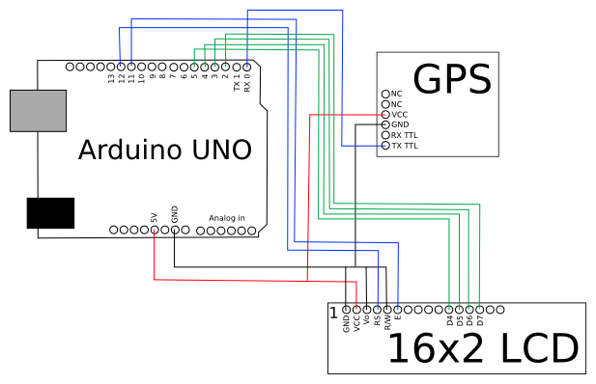

*Figure 4: Hardware design for GPS*

This picture (from google) is an example of how we would use the GPS to connect with the arduino. Specifically we are just looking at how we would connect a GPS to the arduino to work together with the other components as a whole. An LCD would just be used for the load cell approach we are planning on the next section.

#### Section 3.2.2 Approach

Our second approach is similar to the first as to check all components before implementing them. This approach is a little different since this one would still be using bluetooth connection but instead of the VSLAM we would use a GPS component such as the NEO 6M which is very precise. As for the obstacle avoidance we would like some sonar sensors.

#### Section 3.2.3 Anticipated Pitfall and Mitigation Plan

Some of the pitfalls for this approach is the GPS approximation would be not as accurate when it comes to indoor use. As for the sonar sensors, it may take some time for the cart to avoid the obstacles which may not impact the user experience in a good way. To mitigate this problems we would conduct multiple tests indoor and outdoor in different areas to see what would be the difference we obtain in distance. As for the avoidance perhaps work on how much power we give to the wheels and the algorithms used for the avoidance.

#### Section 3.2.4 Anticipated Results

The final result for this is a more price friendly product that can be more accessible and better to perform outdoor rather than indoor use.

### **Section 3.3 Design Objective/Specification 3**

#### Section 3.3.1 Introduction

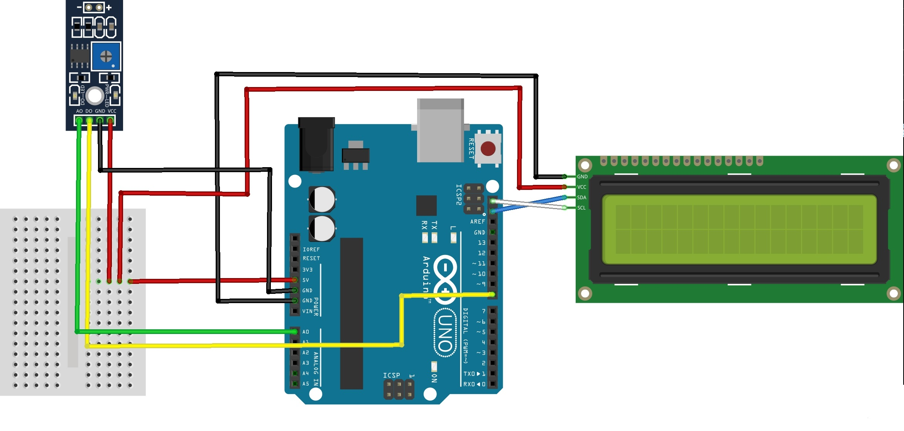

*Figure 5: Hardware Design of Scale*

The picture (taken from google) shows a simple circuit schematic of how we would connect a load cell to the arduino uno. Since we would be using load cell, we wanted to have an LCD that would output a string that denotes if the cart has reached full capacity for carrying items. Simply, we want the LCD to give us the number of how much weight the cart is at.

#### Section 3.3.2 Approach

For our last approach, similar to the previous ones we would first check the components to check functionality accuracy. After checking the components, we would begin to assemble the connection between the load cells, Arduino uno, HX711 module, and LCD. The load cells would be placed under a sheet of wood to gather the weight put on top of it. Along with setting up the hardware, we will need to program some code for the arduino to communicate to gather the data and display it on the LCD.

#### Section 3.3.3 Anticipated Pitfall and Mitigation Plan

The main anticipated pitfall that may occur is that the load cells are giving an incorrect value. This is a big problem for us because we need to know the weight in order to have the cart communicate that it is ready to use or if its weight is over capacity. To mitigate we can try to recalibrate our load cells. After recalibrating we can test again weighing an item on the scale we created and then a calibrated scale. If the data is off we can test a few more items and write in our code to take into account uncertainty $±ΔX$ of our scale.

#### Section 3.3.4 Anticipated Results

We anticipate that the load cell with LCD will work properly. We expect to receive correct data from the load cells that will be used in our code to communicate the next steps for the cart to take.

## **Section 4. Results and Discussions**

Section 4.1 First Approach

The initial idea that our group thought was to simply have a flat platform (Figure 6) that has four wheels, two at the front that is controlled by a DC motor while the two at the back are swivel wheels. Just like the attached picture (Figure 3), we wanted it to be similar to this where we have small barriers at the edge so that the contents are secure when the cart moves fast. In addition, we wanted to add bluetooth connectivity, LCD interaction, and a battery charge of about 2200mAh. However, we didn't expect that the DC motor would not have enough power to move the cart that we designed. As such, we redesigned our project and decided to go with a different approach.

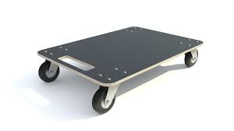

*Figure 6: sample cart*

Section 4.2 Second Approach

The second approach was necessary because of the body of the cart. The dimensions of the cart are 30” x 14” x 3” and weighs 45 lbs on its own. Because of the new design of the cart, everything else had to be adjusted as well. The motors that were originally bought were not strong enough to carry the weight of the cart plus the potential weight of what the cart would carry. The type of motors and battery that would be needed was out of our budget. After doing more research, it was decided that the best and cheapest option would be to buy a used hoverboard, take the motors and battery from it, and implement it into our cart. After purchasing the hoverboard, we took it apart and began to remove the components we needed. From the hoverboard, we kept it’s motherboard, the motors, and battery pack. First thing we needed to do was hack the motherboard and override the original code that was downloaded on it. Then we uploaded a program to test the motors. Once the motors were tested and working, we mounted the motors to the cart. The motors were connected to the wheels; those wheels would control the speed and stirring, and the back wheels would be two swivel wheels that would make the cart’s ability to turn easier.

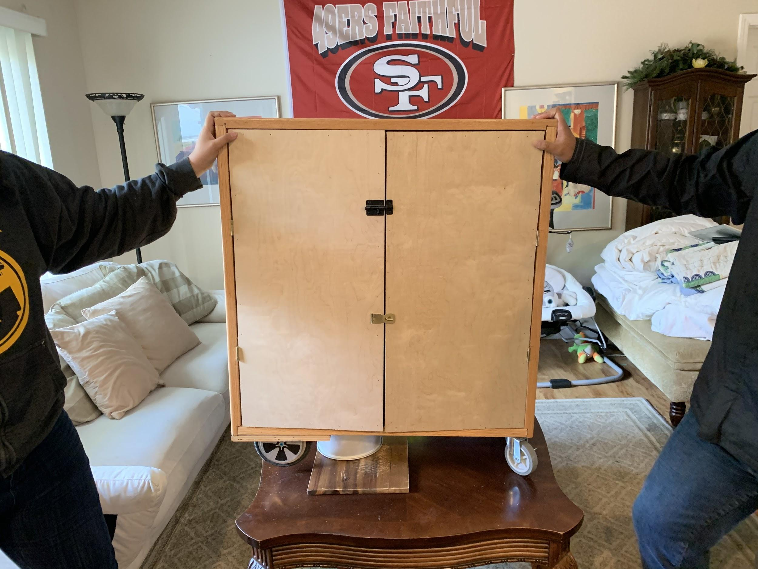 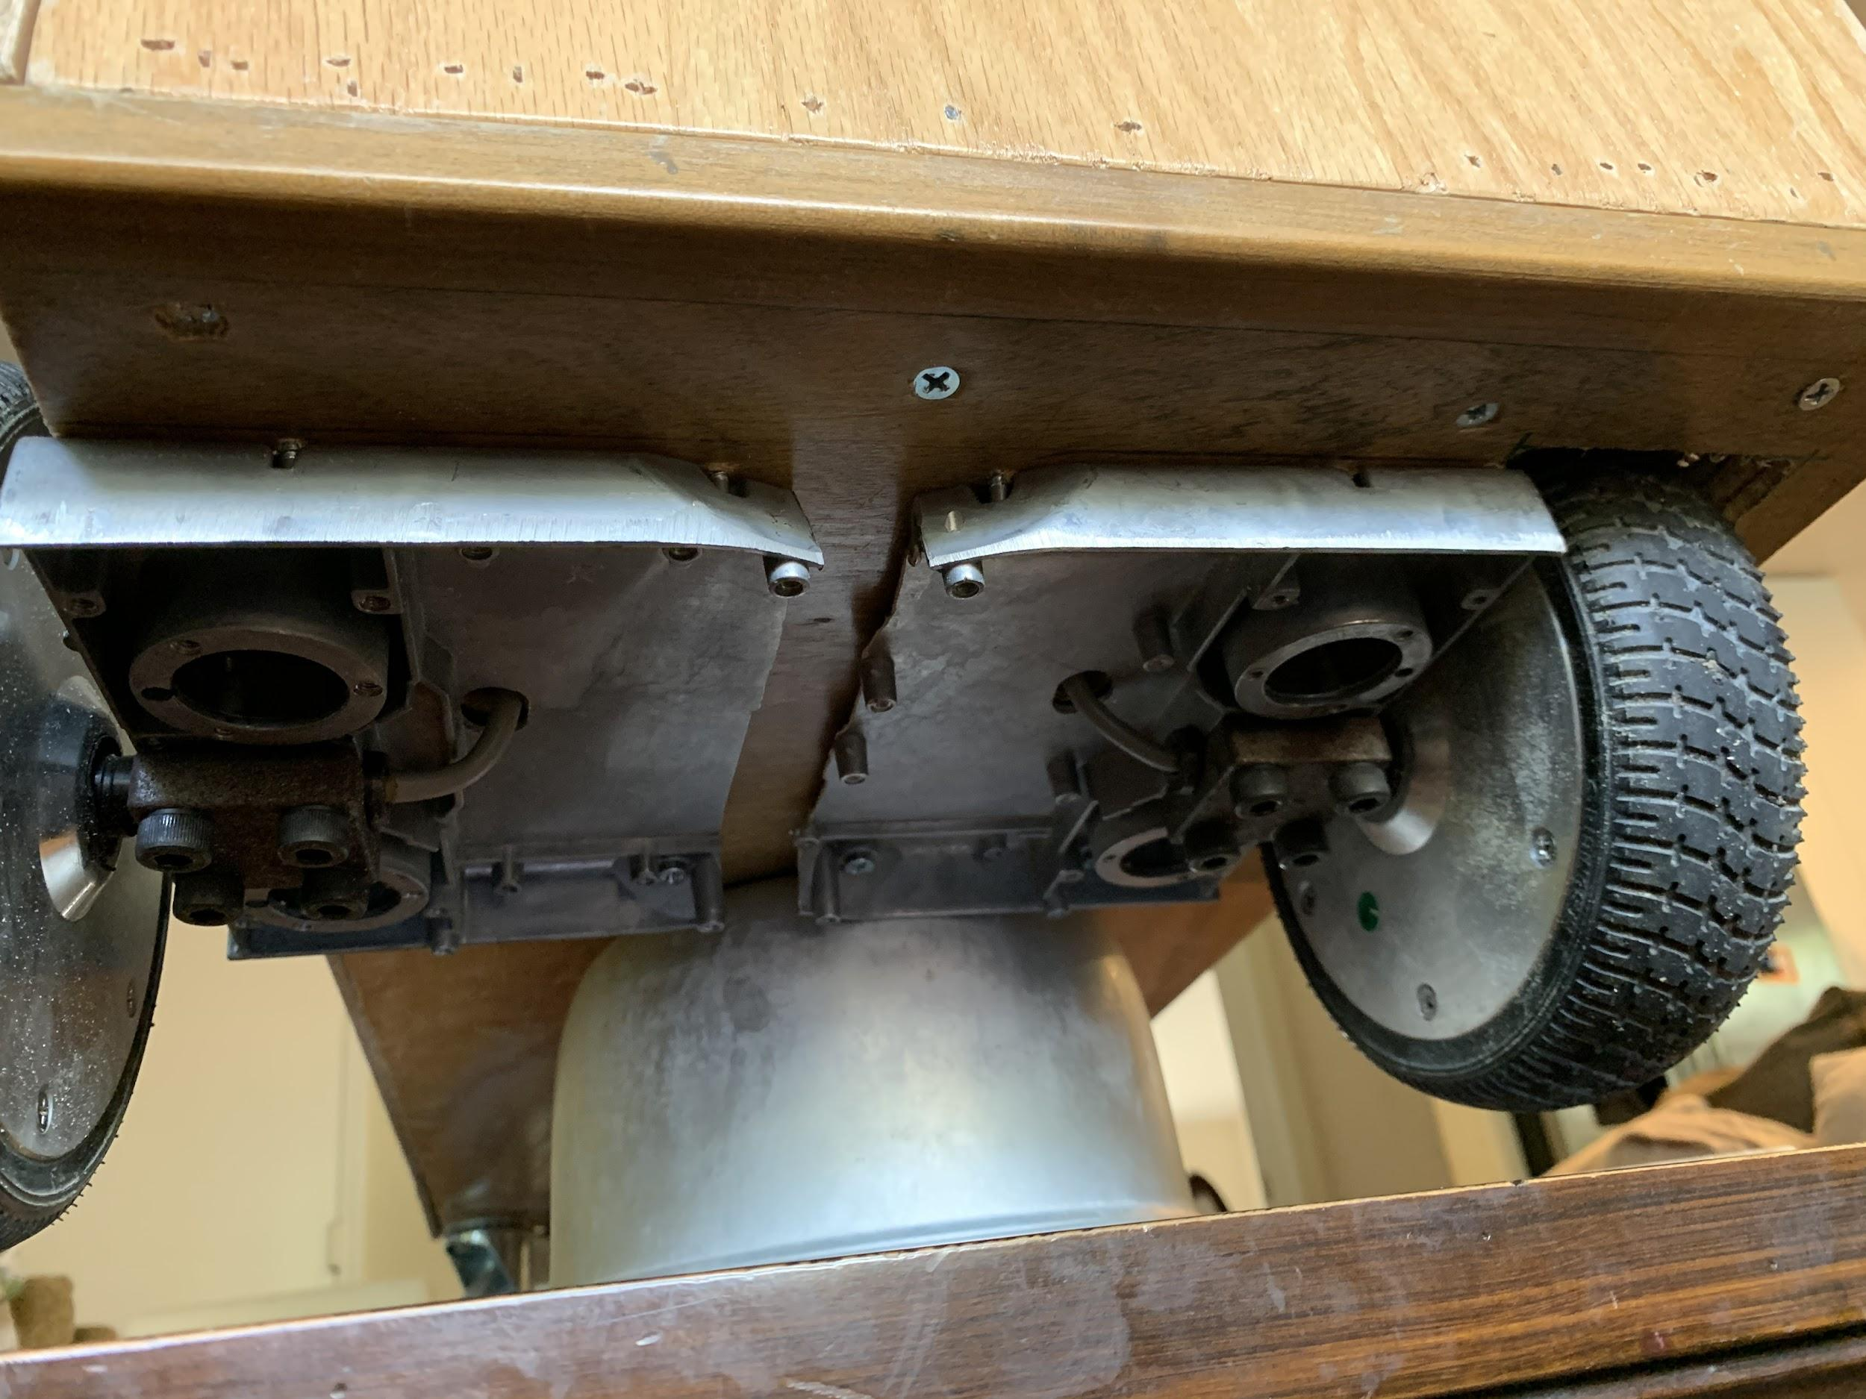

*Figure 7: Body of Cart Figure 8: Mounting motors*

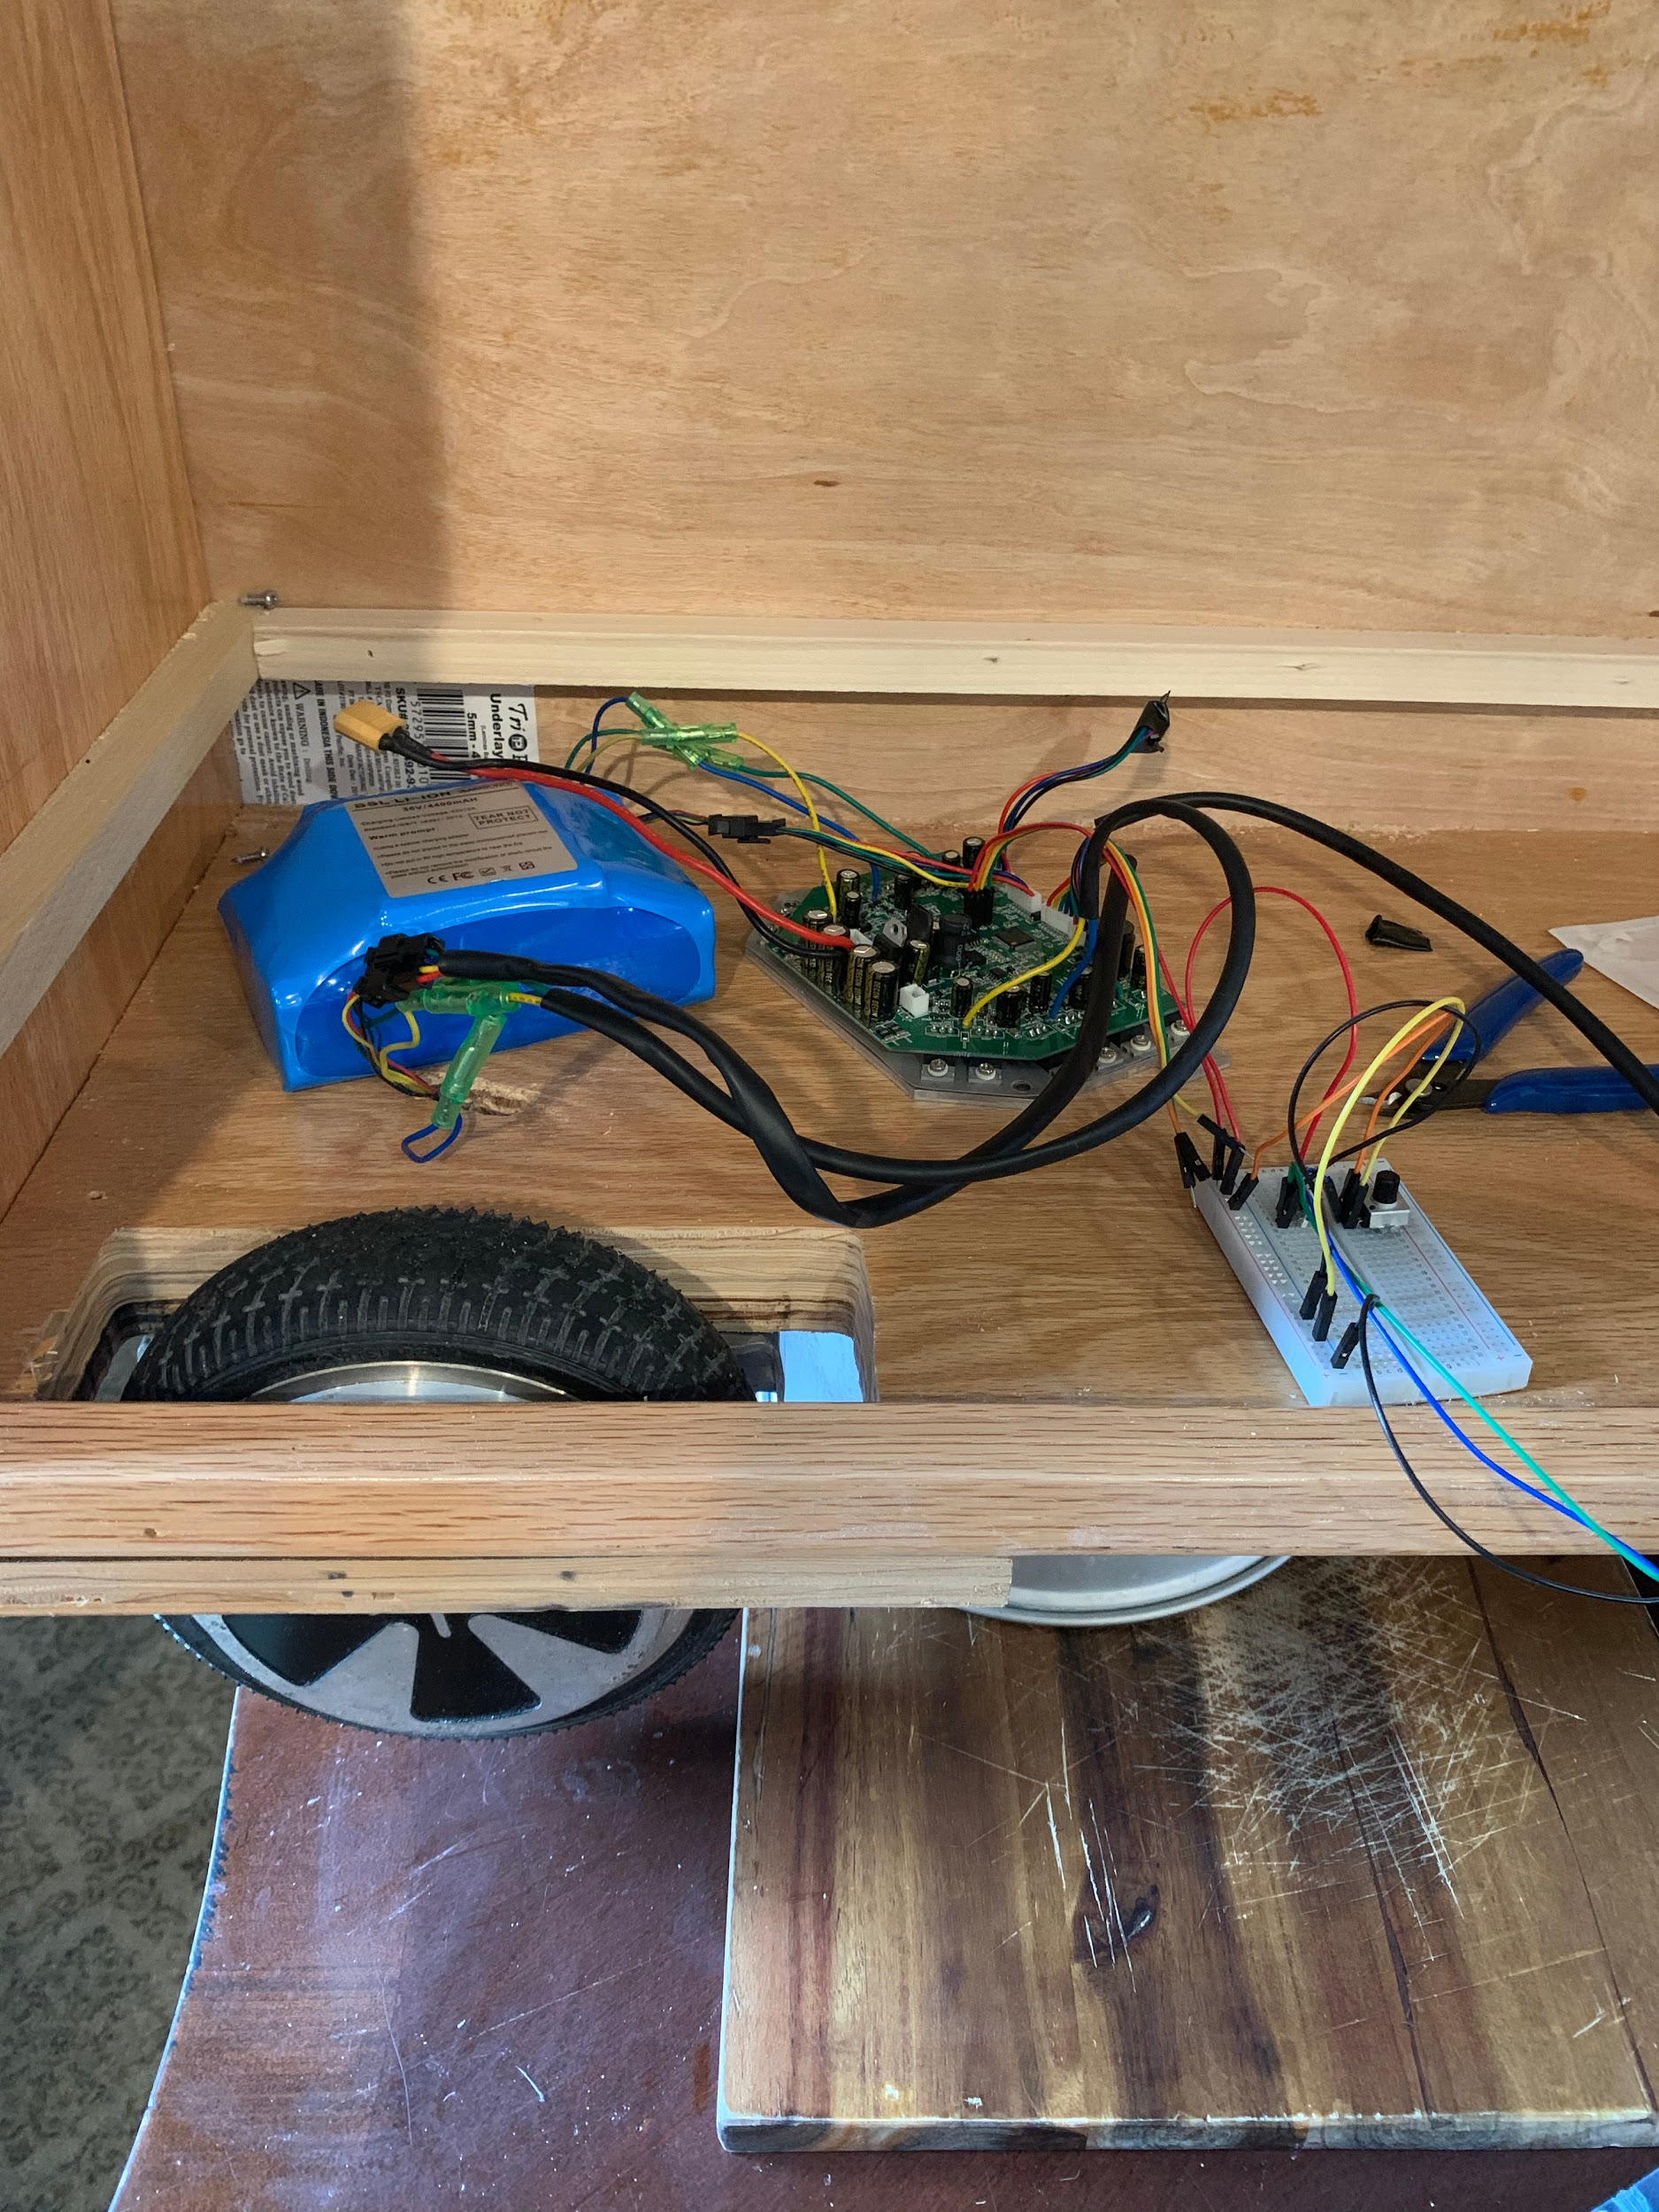 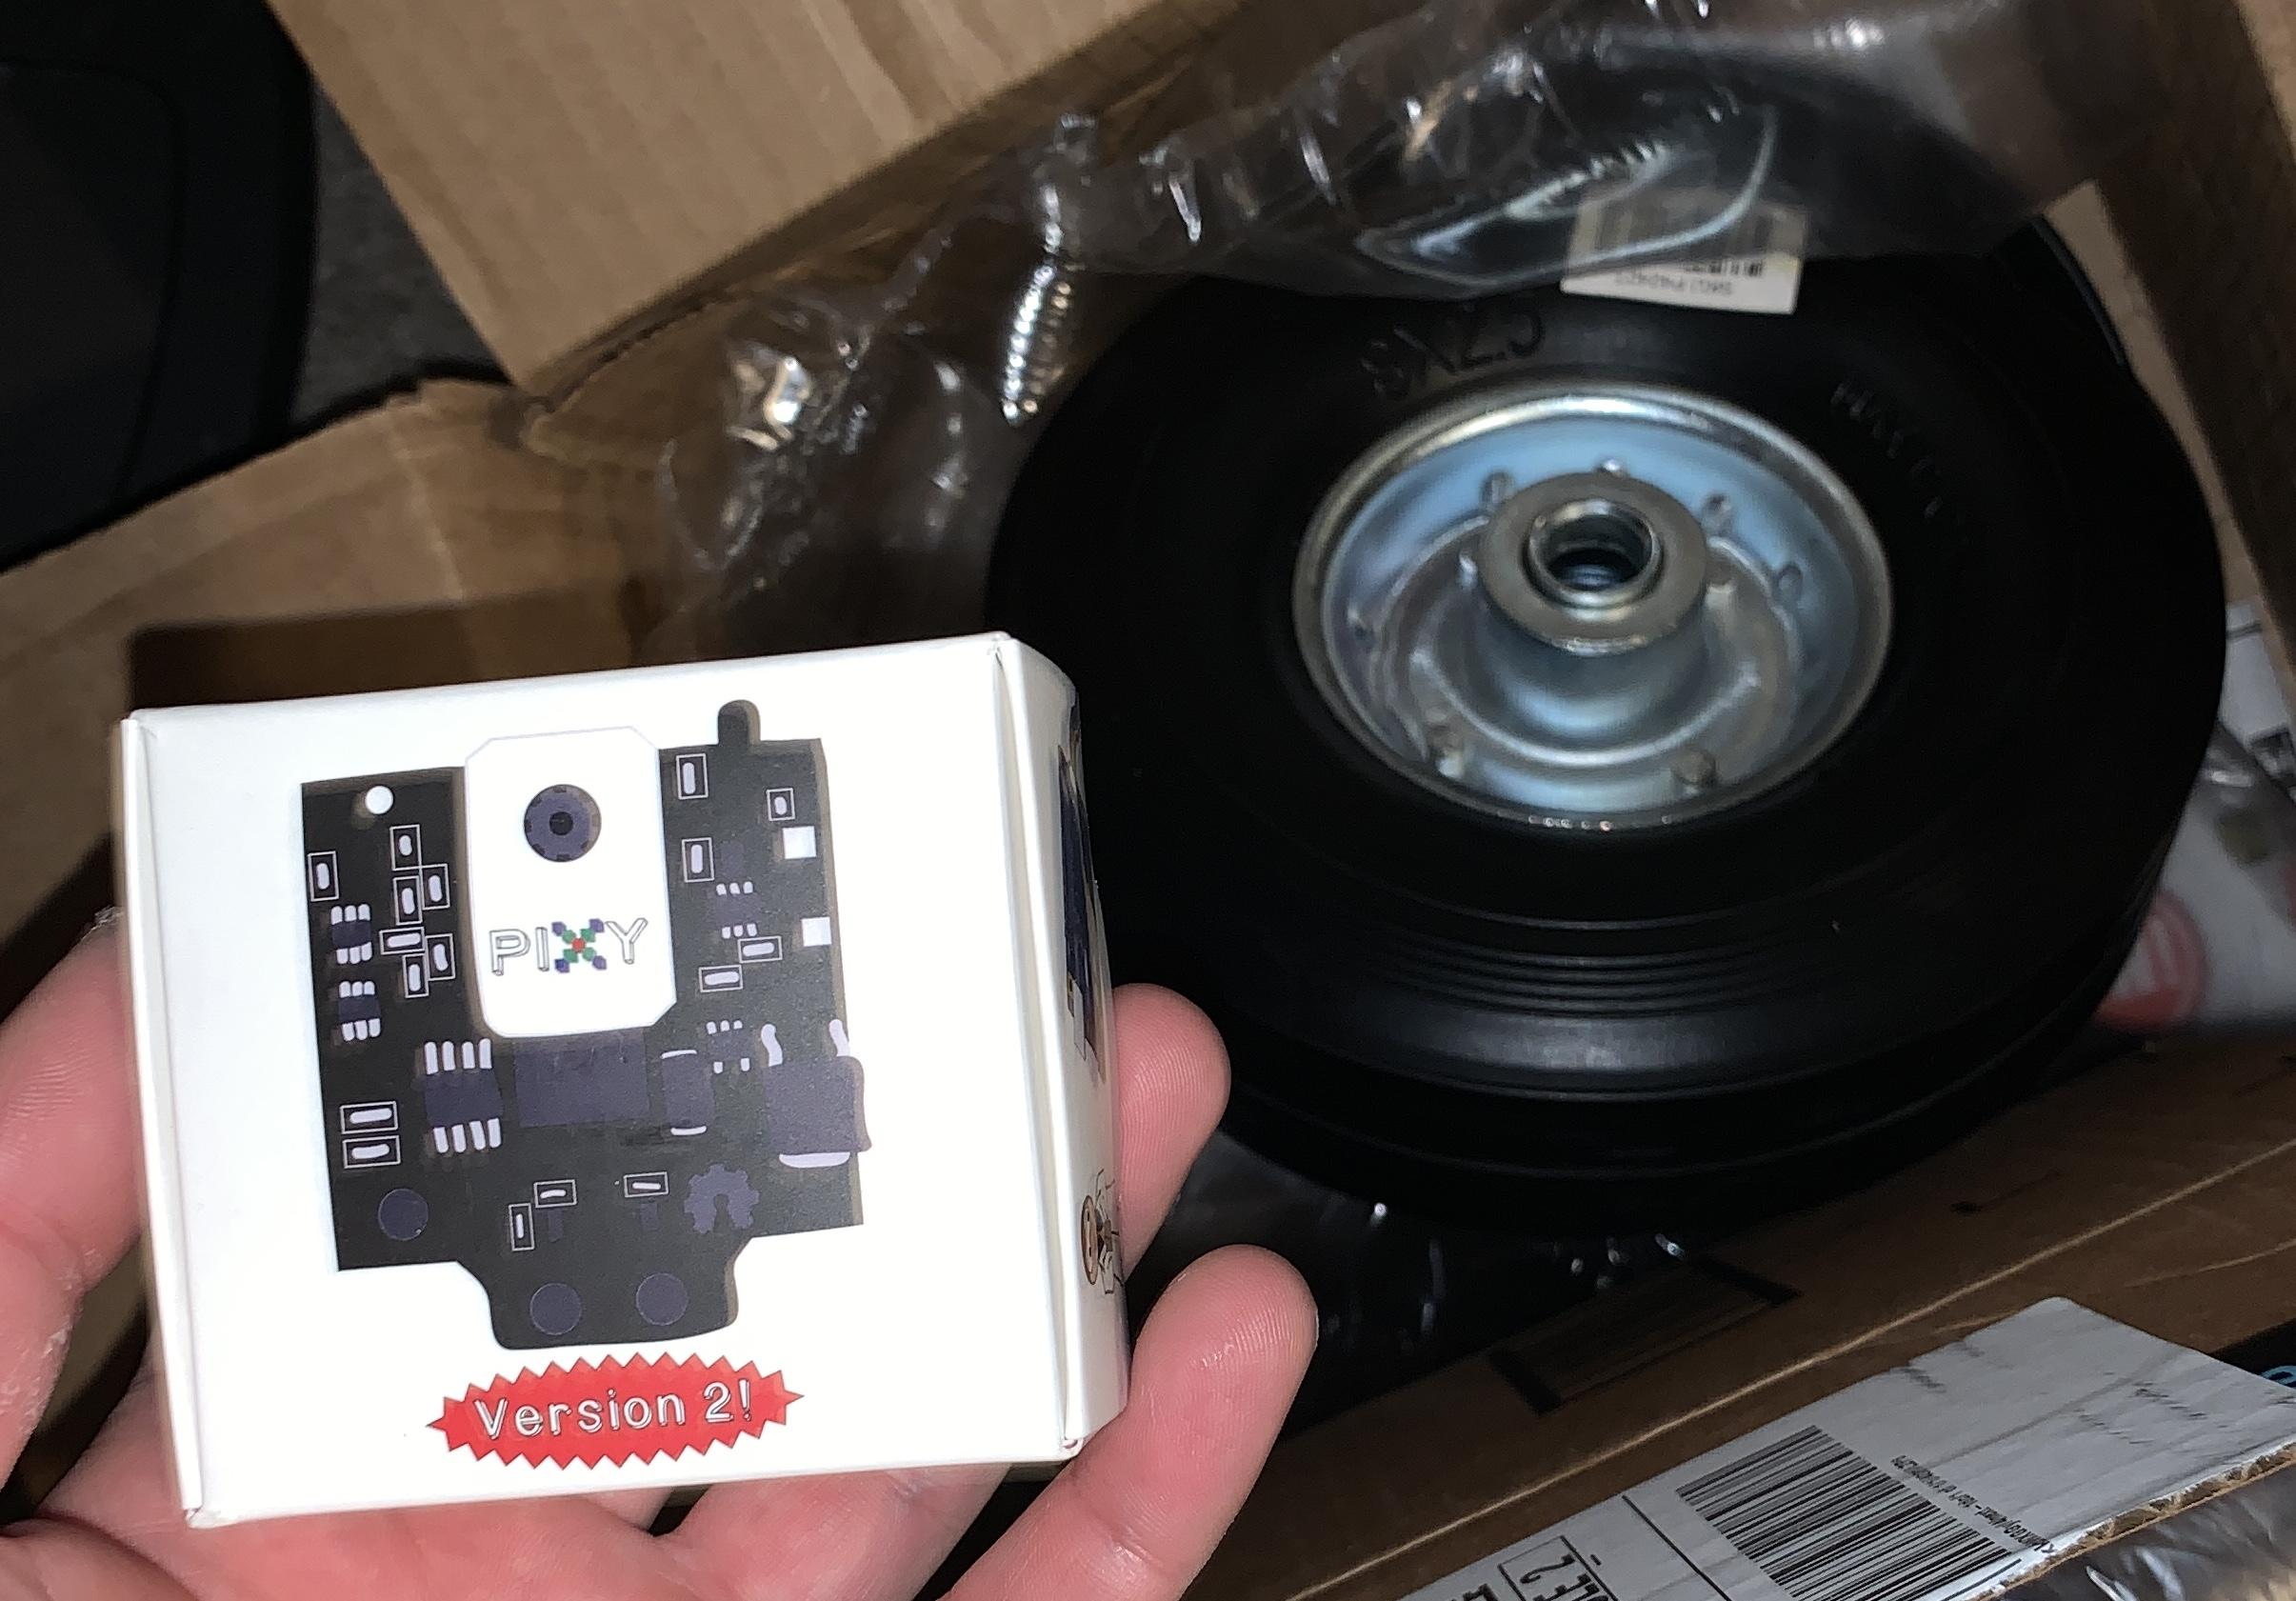

*Figure 9: Hoverboard Components Figure 10: PIXY2 Camera*

The motors were not the only change to our original design, we also wanted to change the way that the cart would follow its owner. Many of the similar products that we researched all used camera sensors to pair and follow the owner. With that in mind, we started to research possible cameras we could use while still making the product cost effective. The PIXY2 camera which uses color detection to pair and follow objects is the camera we went with.

Section 4.3 Final Design

The main change in the final design was how the motors would be controlled. After testing the Pixy in multiple scenarios, we found that the Pixy was not reliable in outside settings. Due to the recent pandemic, the ability to attain certain components as well as the ability to meet together as a group were limited which essentially meant our new design would be limited as well. The modification new design included using a gaming controller to send input signals to the motors for the speed and steering. In order to accomplish this, the components needed are the Arduino UNO, USB Host Shield, USB Adapter, and a PS3 controller. From there we were able to program the controller to pair USB adapters that would connect to the shield that is connected to the Arduino. The PS3 controller then can be used to send the input signals to the arduino which would send the signals to the DACs then to the motors to control the cart.

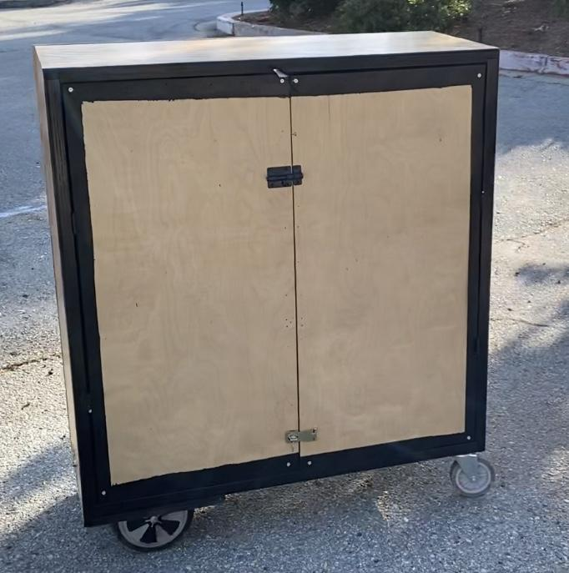 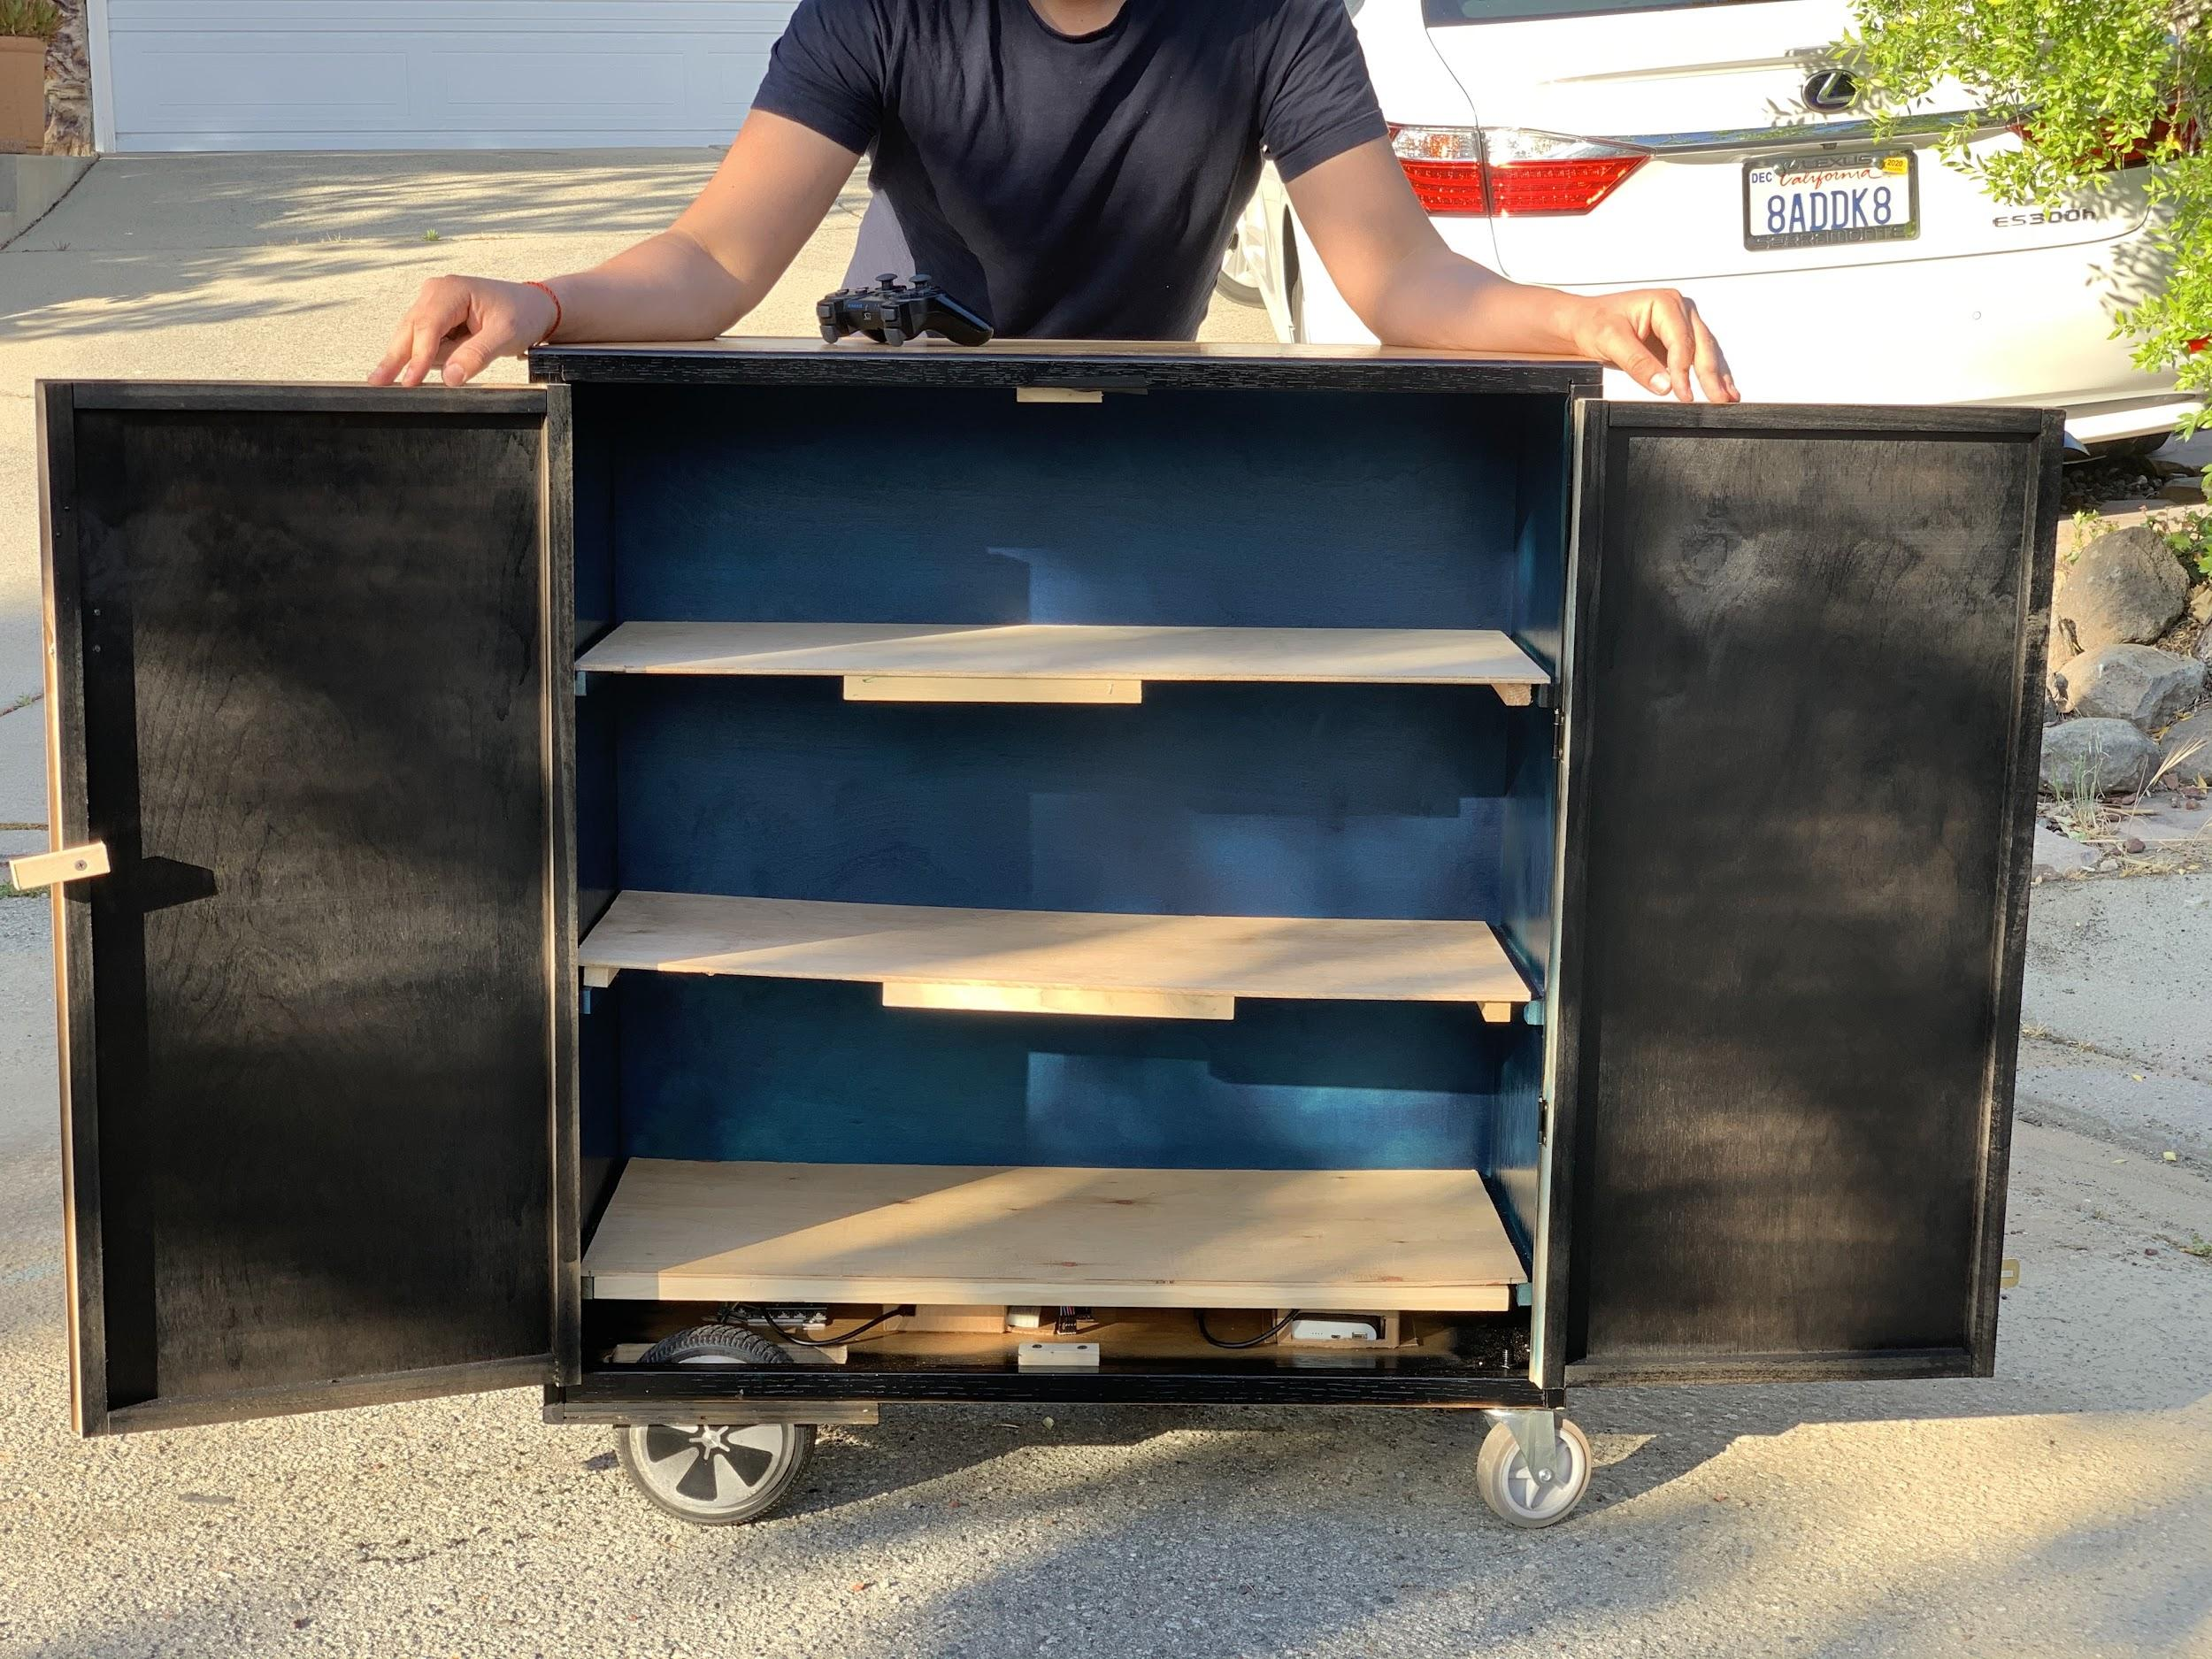

*Figure 11: Cart closed exterior Figure 12: Cart open interior*

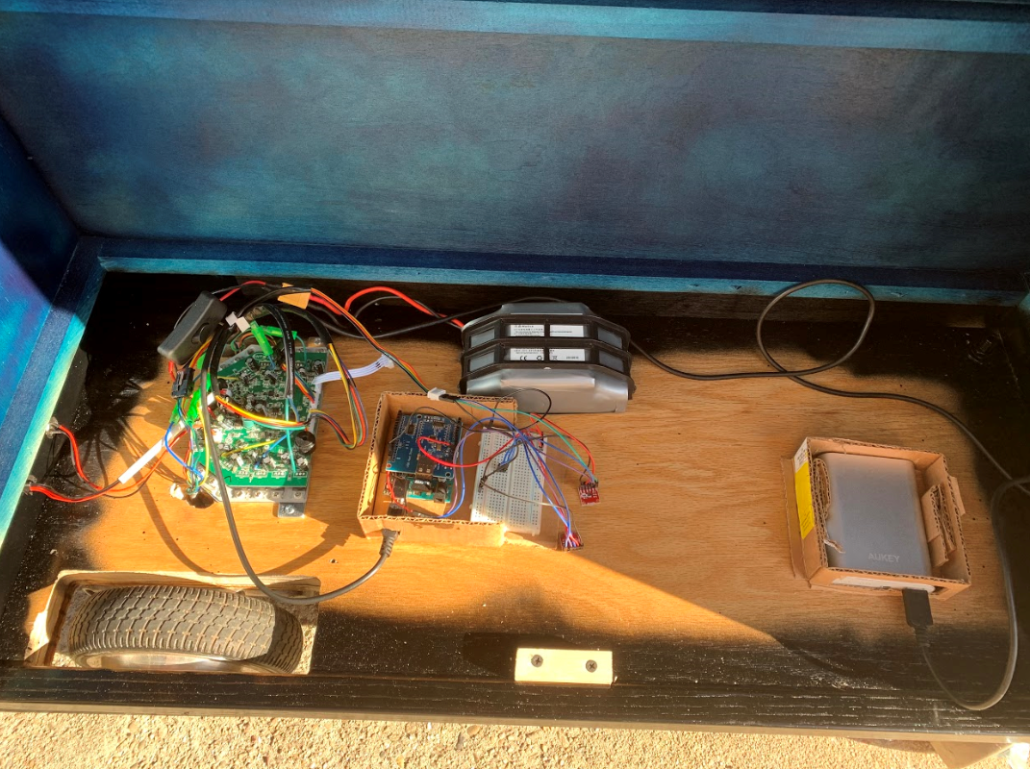 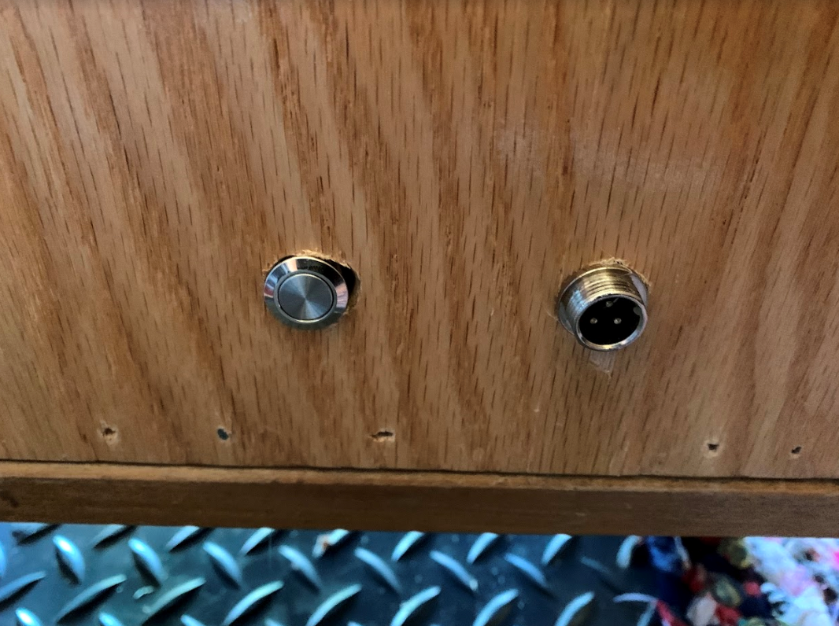

*Figure 13: Cart Final Components Figure 14: Cart’s power button and charging port*

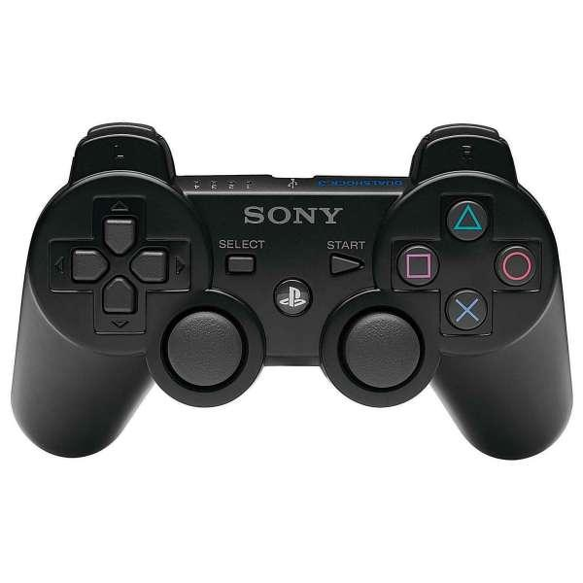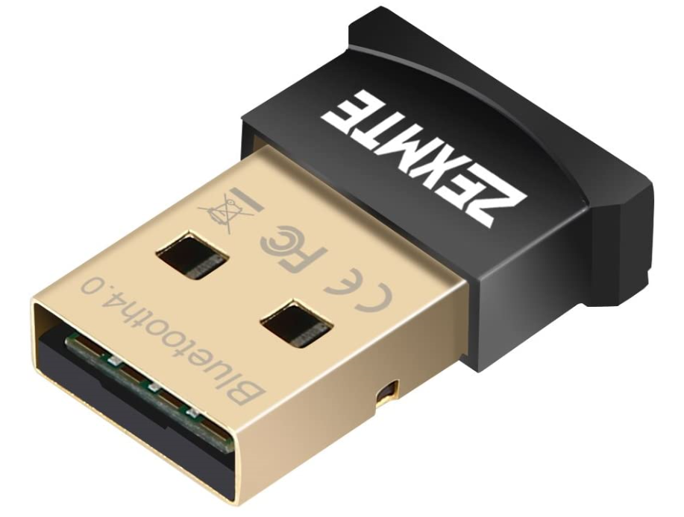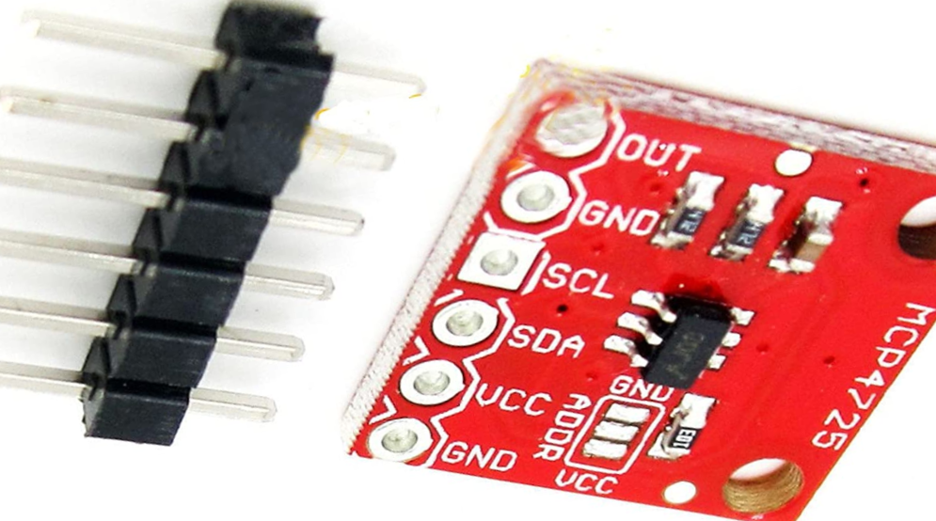

*Figure 15: PS3 Controller Figure 16: USB Adapter Figure 17: Cart’s DACs*

## **Section 5. Self Assessment**

Section 5.1 Lessons

During our time building this project, we didn’t anticipate that there would be a global pandemic (COVID-19). This evidently proved to be a challenge for our group because we could not meet due to the restrictions of stay at home. Regardless, we still had lessons while we were doing this project. The first lesson is that nothing will go as planned. We were initially relying on the idea to move the cart with color detection but as time passed, this proved to be a challenge which made us do a remote control approach. Although we tested the components individually, the results were not enough for us to continue to use the PIXY2 camera as a source of autonomous cart. Second lesson we learned is that it is better to have a backup plan at the very beginning rather than changing the project as obstacles rise. Although we got the remote control idea working, we didn’t pursue it until the very end which even got us more stress because it was a whole new concept compared to the PIXY2. Last lesson we learned is to just enjoy the project. Yes there are some stressful days and times when we want to quit but at the end of the day, we still have to try to make it work. Eventually, the first time that we actually tested if our project work is an amazing feeling filled with joy, relief, and excitement. In the end, we got ourselves a personal remote controlled equipment nicknamed “AutoCart”.

Section 5.2 Improvements

There are a few improvements that we were already thinking when we finished our project. First, we want to go back to the original idea of using hands free (no remote control) equipment. The idea of PIXY2 was for a budget and cheaper route that we wanted to try but it was a challenge to implement with the rest of the cart. We would need a better processing power to detect people accurately and avoid people. Rather than using the PIXY2, we want to use one that would be easier to detect someone and follow that person, perhaps the Jetson Nano. The second improvement we wanted to do is to have a better back wheel. Since our back two wheels are swivel wheels, it goes to every direccion when the cart goes too fast and then suddenly stops. Our idea is to put something in on the side of the wheels so that the wheels won’t go out of control or we just add a different set of wheels. Another improvement is to make the cart visually appealing. We want to finish painting the inside and outside so that we could design it in a unique way that would standout from other projects. Our last improvement, we would want to implement a switch that would toggle between autonomous or remote control. However, this will not work if we can't get the autonomous part working.

## **Section 6. Conclusions**

Overall the project was a success. We were able to adjust our project to meet the difficulty that the COVID-19 had on us. Rather than using the PIXY2 for our color detection, we shifted gears to a remote control (PS3 controller) to have a better response between the consumer and the cart. Although the idea of using the PS3 controller as a way to control the cart is essentially not “autonomous”, it was still the better idea rather than pushing the cart. Due to the use of hoverboard motors, the cart can carry heavier weight with no problem. In the end, we built a cart that is much like a friend who can help carry things for you.

## **Reference**

Brown, Dalvin. “Gita Is a New Cargo Robot That Can Follow You, Carry Your Stuff for about 4 Hours.” USA Today, Gannett Satellite Information Network, 18 Oct. 2019, <https://www.usatoday.com/story/tech/2019/10/18/gita-personal-robot-valet/3998545002/>.

“How to Interface GPS Module (NEO-6m) with Arduino.” Arduino Project Hub, <https://create.arduino.cc/projecthub/ruchir1674/how-to-interface-gps-module-neo-6m-with-arduino-8f90ad>.

Pravin, et al. “How to Connect Arduino Uno to Android via Bluetooth.” *Electronics Hub*, 25 Dec. 2017, https://www.electronicshub.org/arduino-android-communication-using-bluetooth/.

Robotics, ForwardX. “Ovis: 1st AI-Powered Suitcase Following by Side.” Indiegogo, 29 May 2018, <https://www.indiegogo.com/projects/ovis-1st-ai-powered-suitcase-following-by-side>

## 

## 

## 

## 

## 

## 

## 

## 

## 

## 

## 

## **Appendix**

Part of the code used to control the speed and steering

